SIR APOLLO KAGGWA SCHOOLS
MID TERM II - 2024
ENGLISH
PRIMARY ONE

My name is ________________________________________________
Class ______________________________________________________

1. Arrange these letters in a,b,c (alphabetical) order
(a) e, d, g, f ______________ (b) z, x, y, w ______________

2. Fill in ‘a’ or ‘an’ correctly.
(a) Here is _____ egg.
(b) ____ teacher teaches pupils.
(c) I have _____ orange and _____ mango.

3. Match the opposites correctly.
(a) fat strong
(b) weak dirty
(c) clean thin
long
4. Fill in the missing letters.
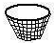
(a) mang __ __s
(b) b__sk__ts

(c) __ __ __anas
5. Circle the compound word in a sentence.
(a) Our goalkeeper played very well.
(b) The boy has broken his inkpot.
(c) The newspaper is on the table.

6. Get a small word from the big one.
(a) elephant ____________ (b) teacher ___________
(c) today __________

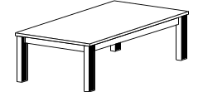
7. Fill in the gaps with under, on, in or over.
(a) The flower is ___________ the table.

(b) The birds are flying ________ the hills.
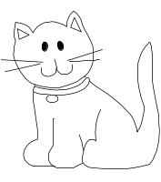
(c) The cat is sitting _______ a box.

(d) The ruler is _______ a tin.

8. Fill in ‘is’ or ‘are’
(a) The kittens _______ playing in the grass.
(b) He ______ washing his shirt.
(c) The girls _____ very clean.
9. Circle the odd member in each group.
A | B | C | D
chair  bench  broom  table | dress  shirt  trouser  fork | mat  sty  kraal  nest  hutch | mango  orange  cabbage  pineapple

10. Tick √ the nouns in the sentences.
(a) She is called Sarah.
(b) Today is Thursday.
(c) I live at Kansanga.

11. Use the correct tense of the word in brackets.
(a) Mother is _____________ food. (cook)
(b) Jesca _______________ to Nairobi last week. (go)
(c) I am _______________ on the chalkboard. (write)

12. Use ‘has’ or ‘have’ to make sentences from the table below.
Mary  I  We  He | have  has | a red apple.  many books.  pencils and books.

- _______________________________________________
- _______________________________________________
- _______________________________________________
13. Punctuate correctly.
(a) where is your bag
________________________________________________
(b) tom is sick
___________________________________________________
(c) Here is Toms pencil
_________________________________________________

14. Use Yes, it is. No, it is a

(a) Is this a window?
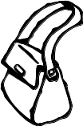
__________________________________________
(b) Is this a bag?
_________________________________________

15. Write these words in small letters.
(a) APPLE _____________
(b) SCHOOL _______________
16. Read and draw.
(a) The cat is chasing a rat.

(b) James is carrying a big box.

(c) Sarah is sitting under a big tree. She is reading a book.

17. Match the pictures to their correct pronouns.
It
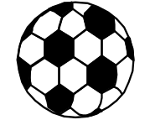
She

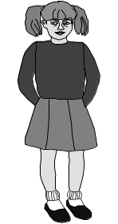
They

We

END
P1 English End of term I 2024
- (a) d, e, f, g
- w, x, y, z
- (a) an (b) A (c) an, a
- fat – thin
weak – strong
clean – dirty
- (a) oe (b) a e (c) ban
- (a) goalkeeper (b) inkpot
(c) newspaper
6. (a) ant
(b) teach/each/her
(c) to/day
7. (a) under (b) over
(c) on (d) in
8. (a) are (b) is (c) are
9. (a) broom (b) fork
(c) mat (d) cabbage
10. (a) Sarah (b) Thursday
(c) Kansanga
11. (a) cooking (b) went
(c) writing
12. Mary has a red apple/Mary has many books/I have a red apple/I have many books/We have many books/We have pencils and books/He has a red apple/He has many books.
13. Where is your bag?
Tom is sick
Here is Tom’s pencil
14. No, it is a door.
Yes, it is.
15. apple
school
16. Mark clear pictures.
7. cats – They
ball – It
girl - She

